* The main objective of the experiment is to understand underlying patterns of the available data. For this purpose, a study is made on how the stocks are correlated with each other which can aid in predictive analysis of data which means understanding if the values of previous stocks can be used to predict the future stock values.
* The data is in a structured form. This is time series data since the stocks are taken for each day throughout the year 2017. The dataset contains stock data for the companies FACEBOOK, AMAZON, GOOGLE, NVIDIA and IBM. The datasets contain 251 rows and 6 columns of which the open and close values for each dataset are important for a financial data analyst. The datasets have been taken independent of each other which means they are not merged. They are not reduced either.
* Analysis of each experiment individually:

1) Normalizing the data

The data has been normalized using the min-max normalization technique. Below are the sample screen shot of normalized data for AMZN dataset:

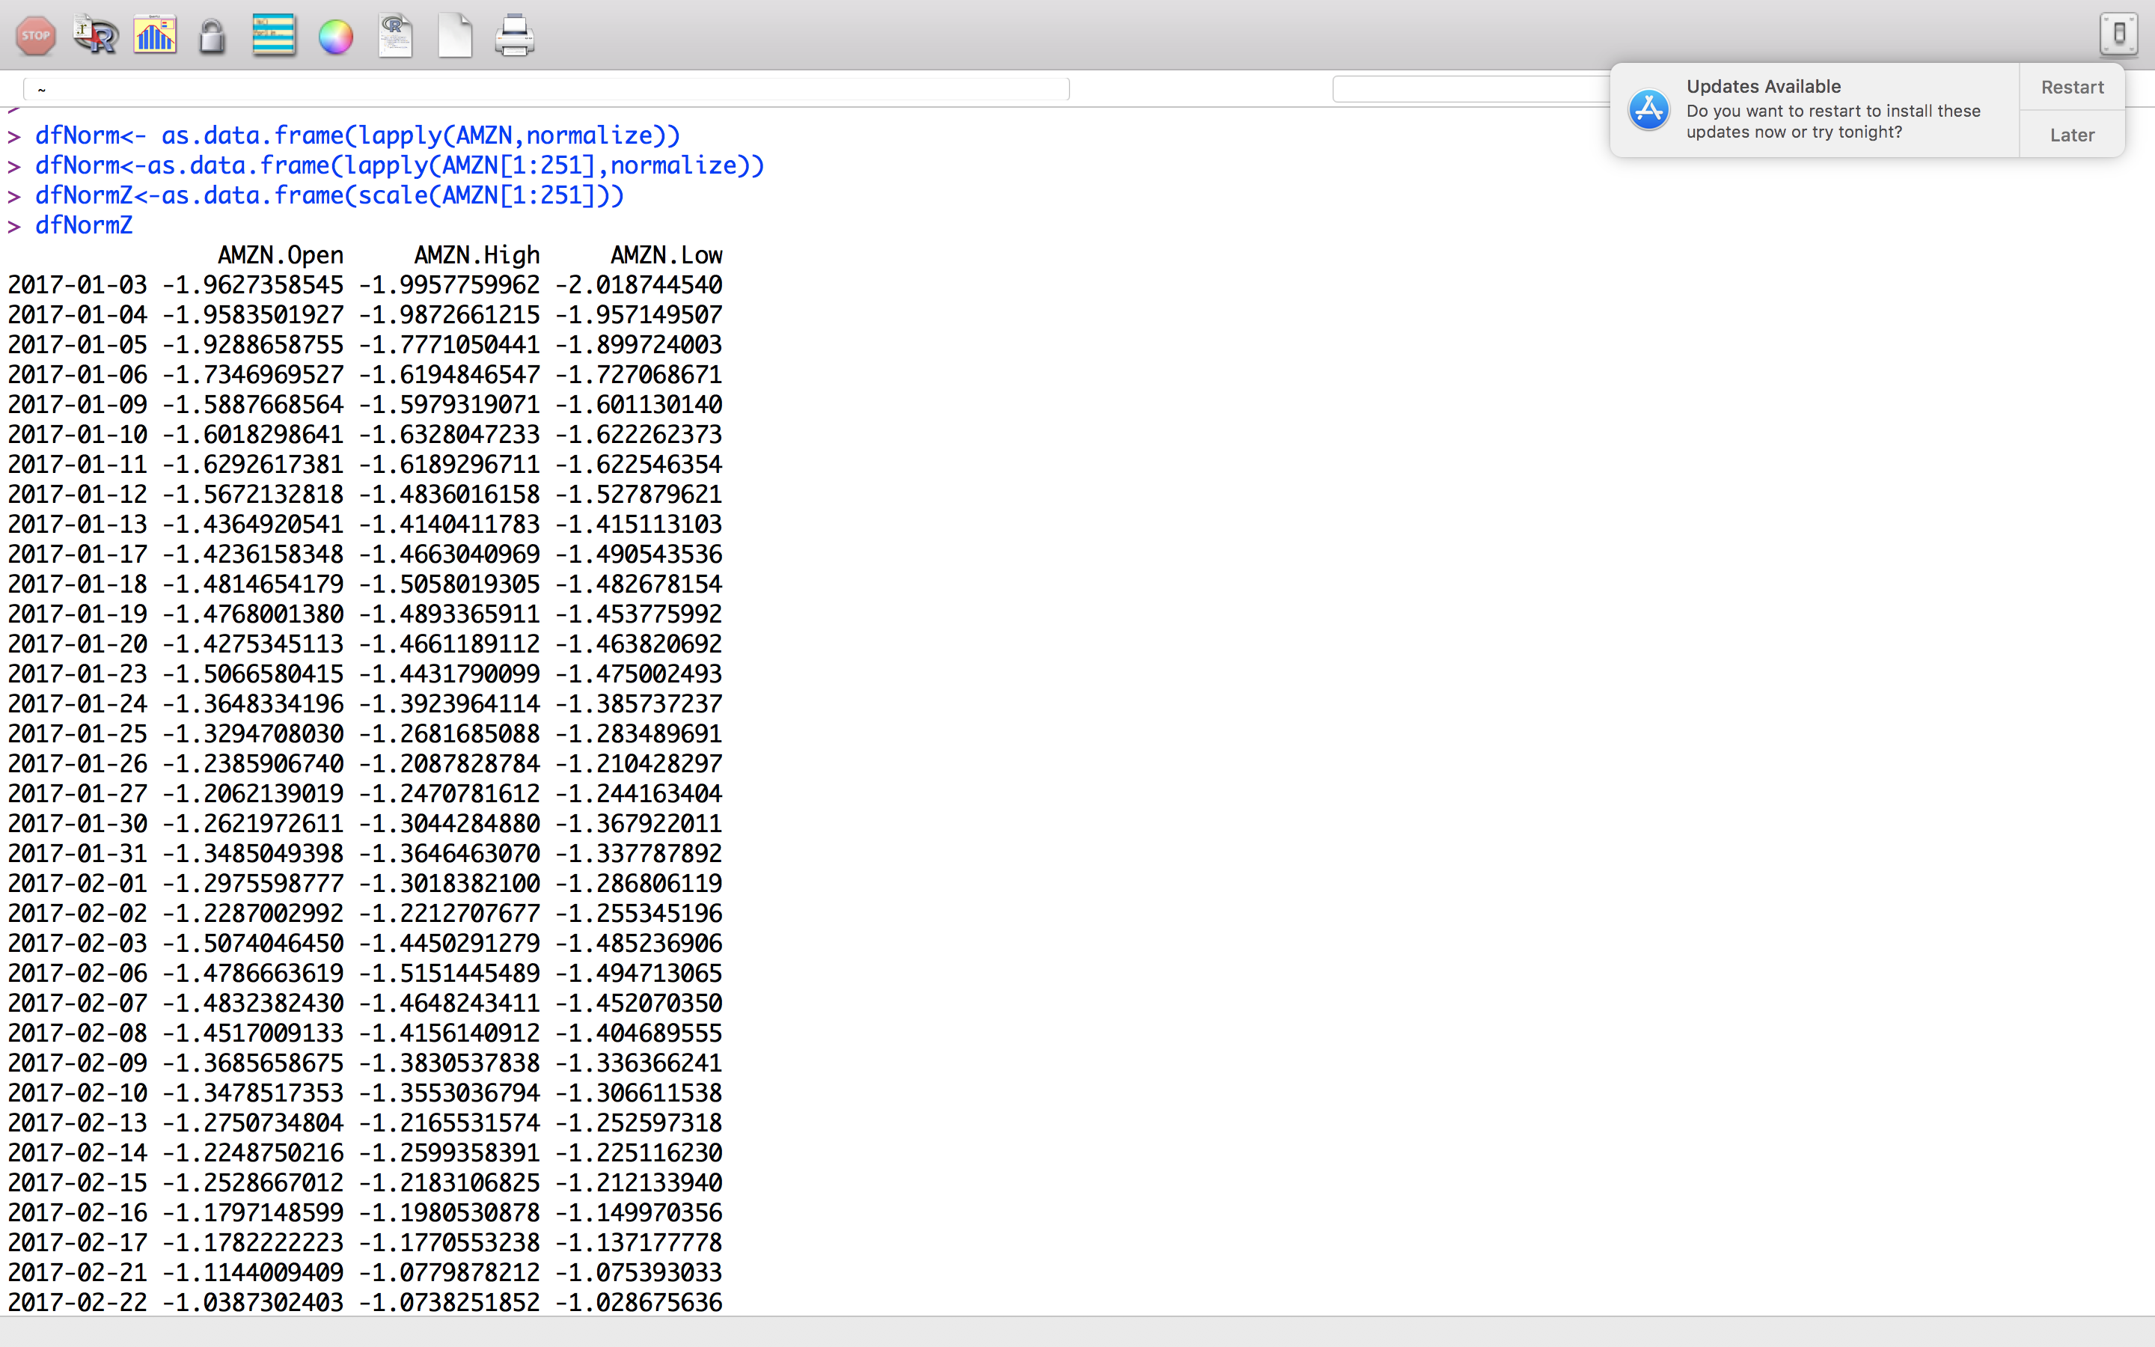

2) The profitability of the companies:

AMZN: ((1169.47-753.67)/753.67)\*100=55.1%

FB: ((176.46-116.86)/116.86)\*100=51%

NVDA :((193.5-102.01)/102.01)\*100=89.6%

IBM :((153.41-167.19)/167.19)\*100=–8.2%

GOOG :((1046.4-786.14)/786.14)\*100=33.1%

Hence, the most profitable company is NVDA and the least profitable company is IBM. This is calculated relative to percentage change in the closing stocks for the year 2017.

3) It is important to know how the stocks of two companies are correlated in order to understand if the pattern of growth is linear with respect to closing values of stocks for one company to another. If it equals 1 or close to 1, it means two companies have a strong positive correlation with each other that is, as x increases y increases. If it is -1, then they are strongly negatively correlated with each other that is, x decreases as y increases and vice versa. A correlation of 0 means that there is no linear relationship between the two variables. Below is a graph that indicates the correlation of closing values between all the companies.

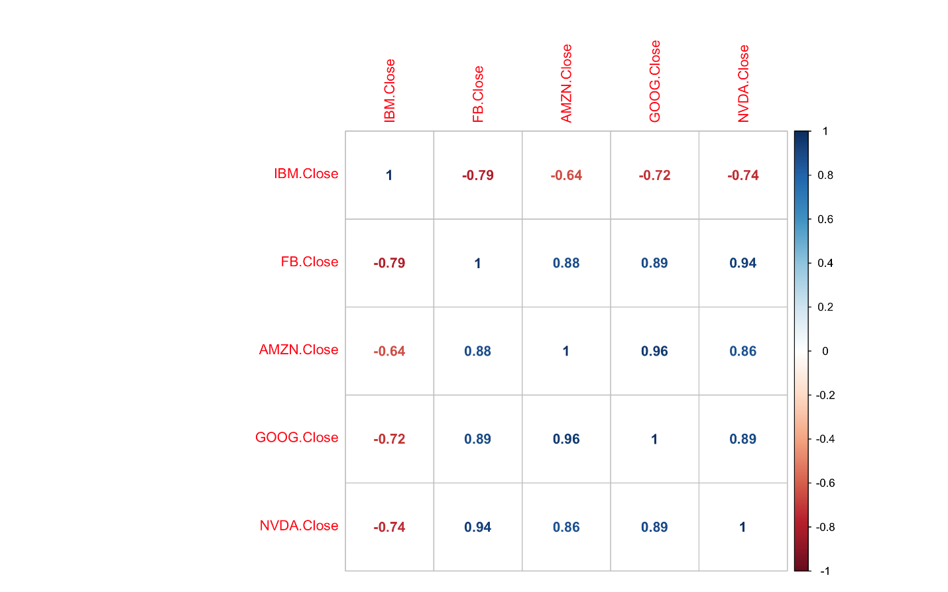

From this graph it can be said that the IBM does not have linear relationship with any of the companies. While Amazon and Google have a strong positive correlation with each other.

4) The same step as in step 3 is repeated but we have performed correlation for each pair by offsetting values by -2,-1,+1 and +2 days respectively. By performing correlation this way, we observe the following changes in the graphs as below: ( all comparisons of correlation values has been made with the original correlation set which is the above set)

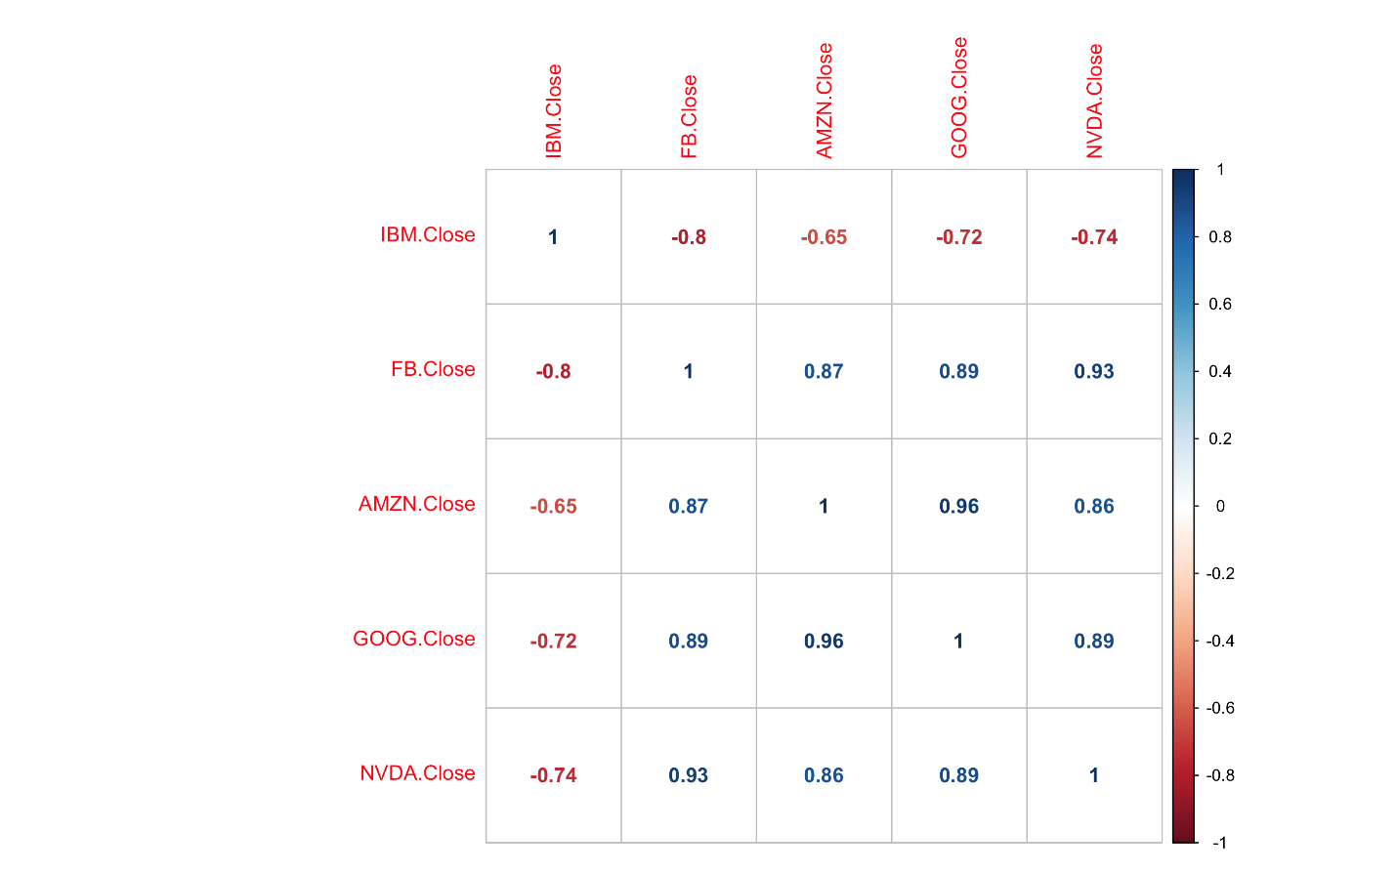(FB offset by –2 days with all other pairs): The correlation has been decreased by 0.01.

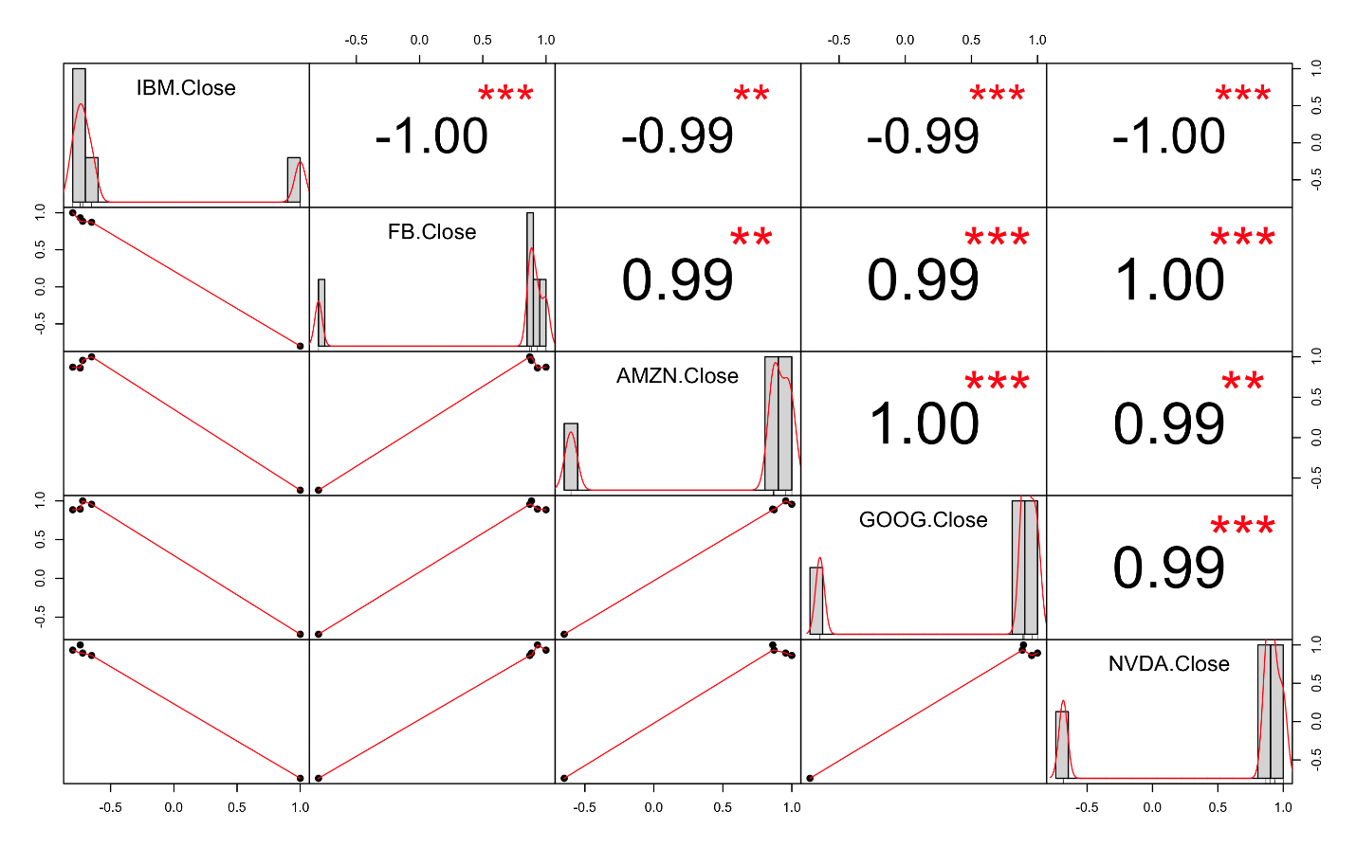

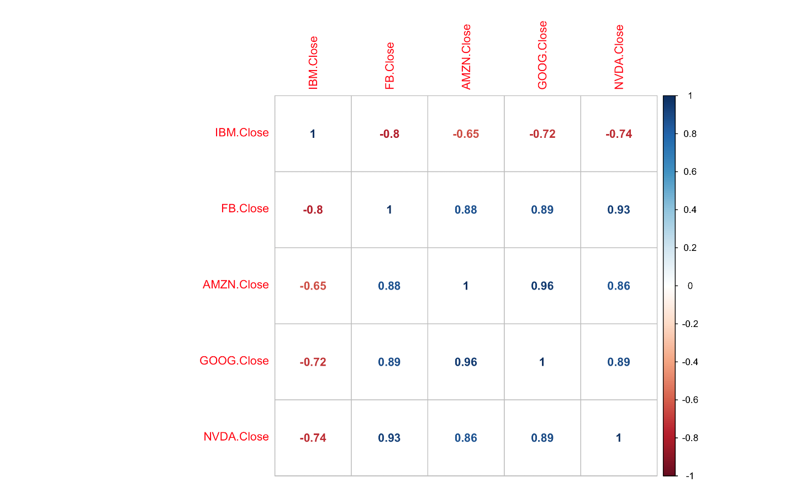

FB offset by -1 day with all other companies: The correlation values with NVDA and IBM have been affected.

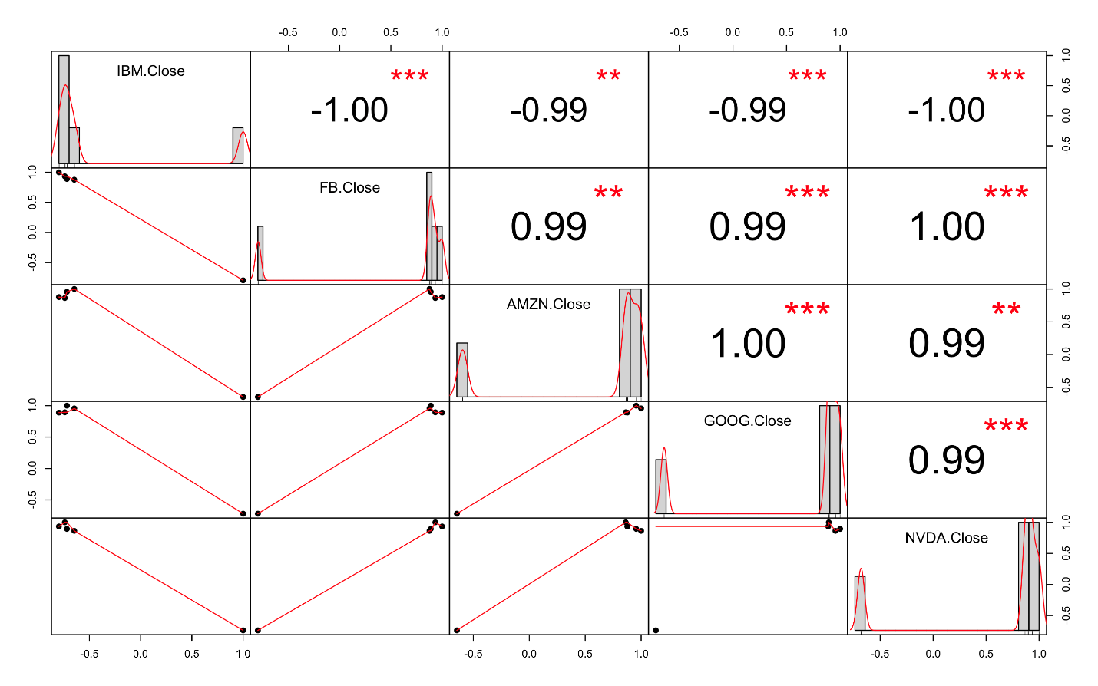

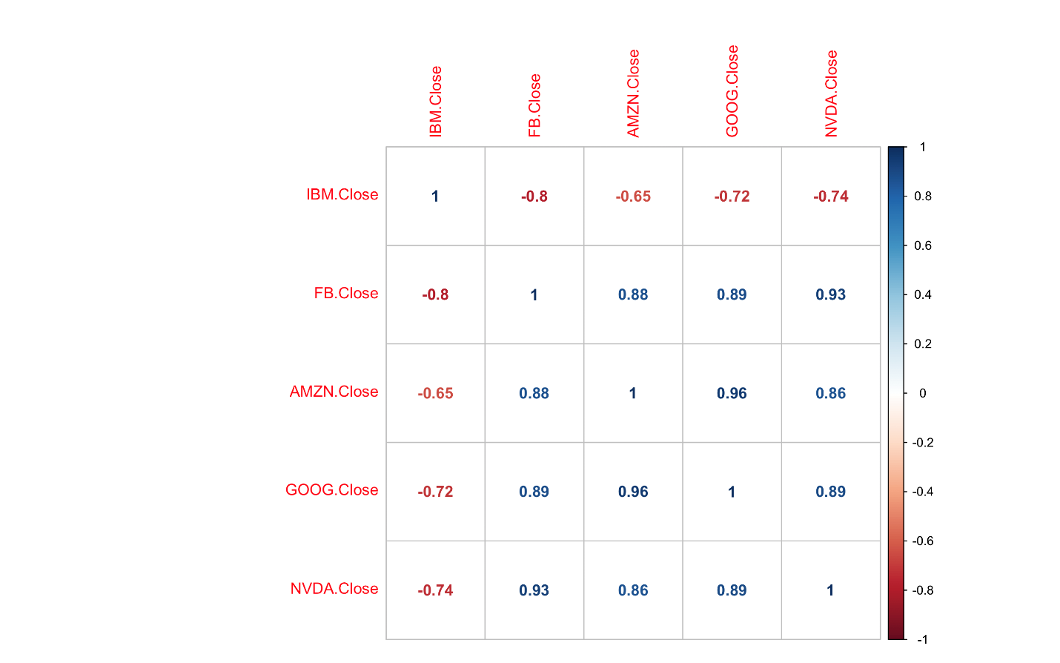

FB offset by +1 day with other companies: Same result as before



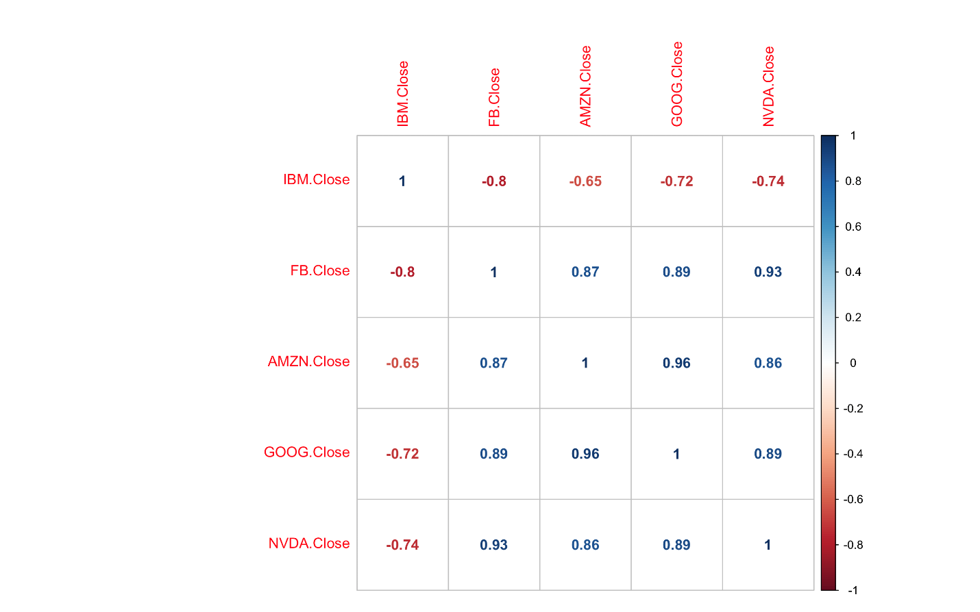

FB offset by +2 days with all other companies: Correlation is decreased by 0.01

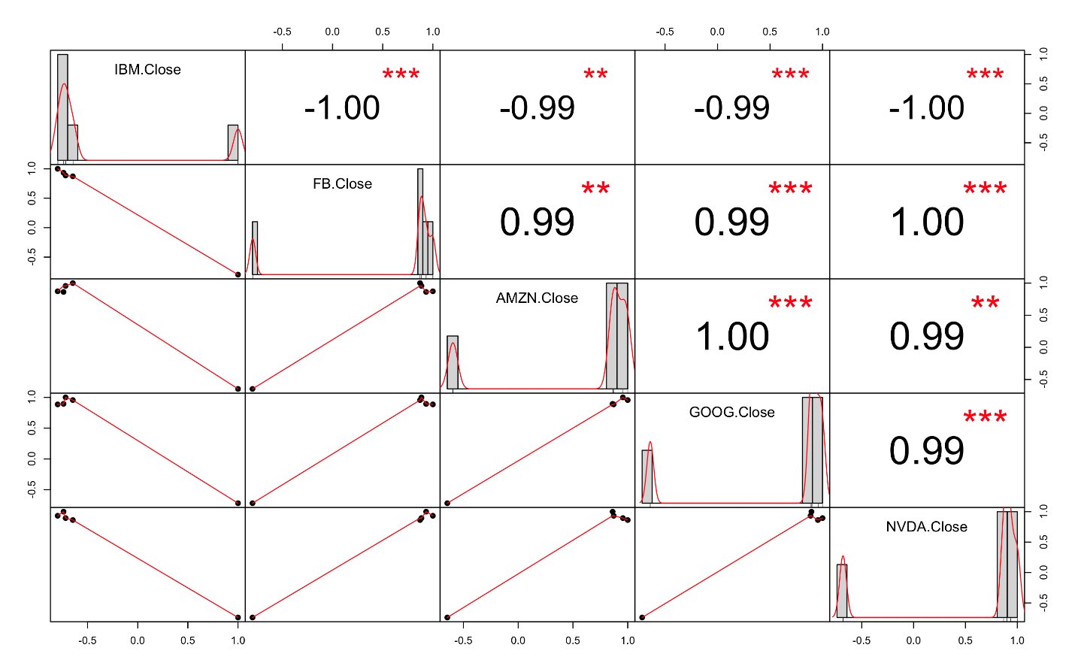

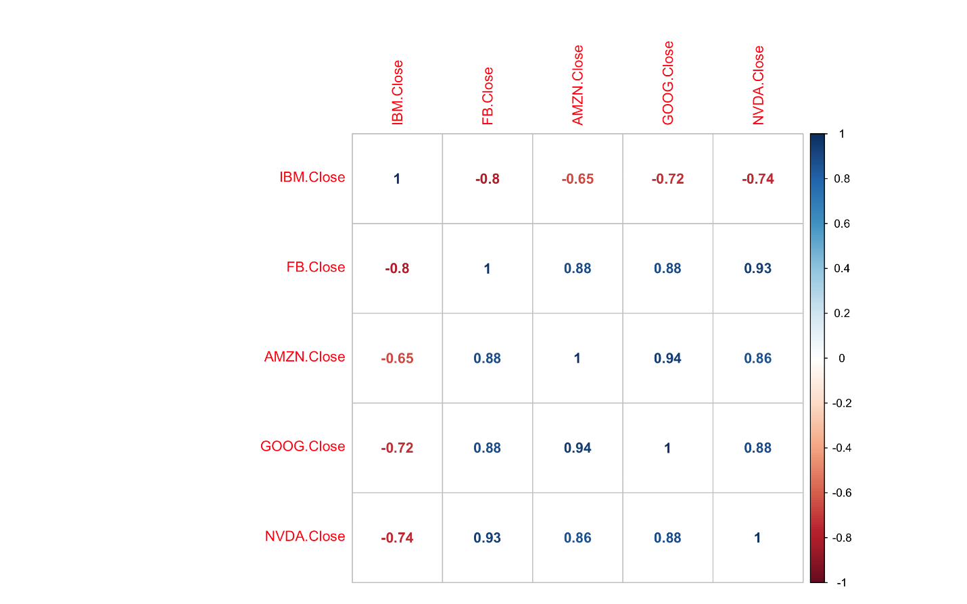

GOOG offset by -2 days with other companies: Correlation has been decreased.

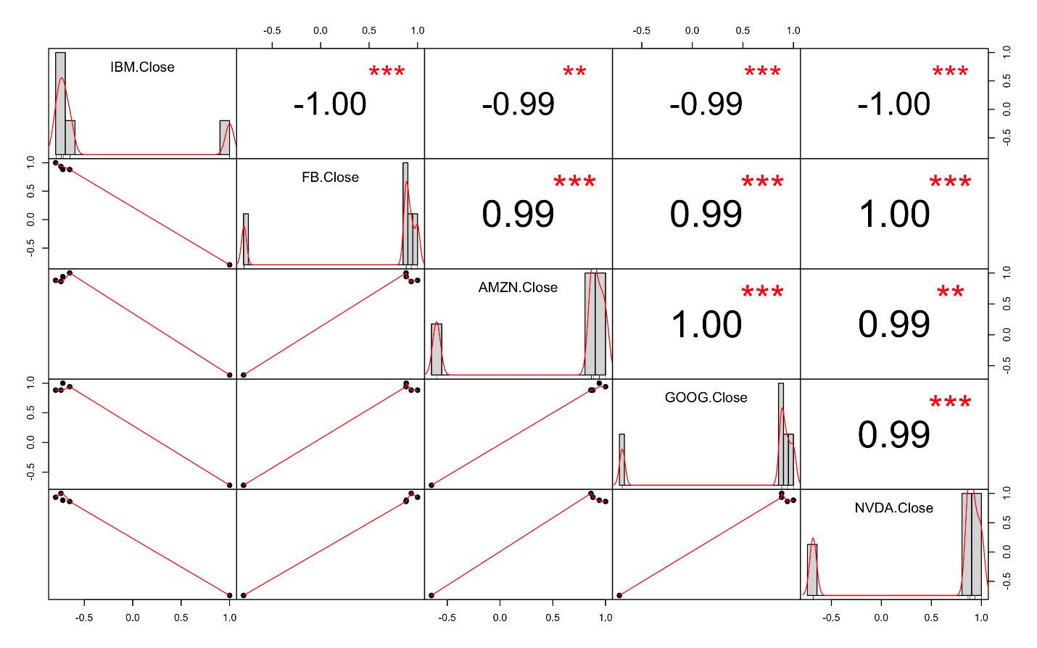

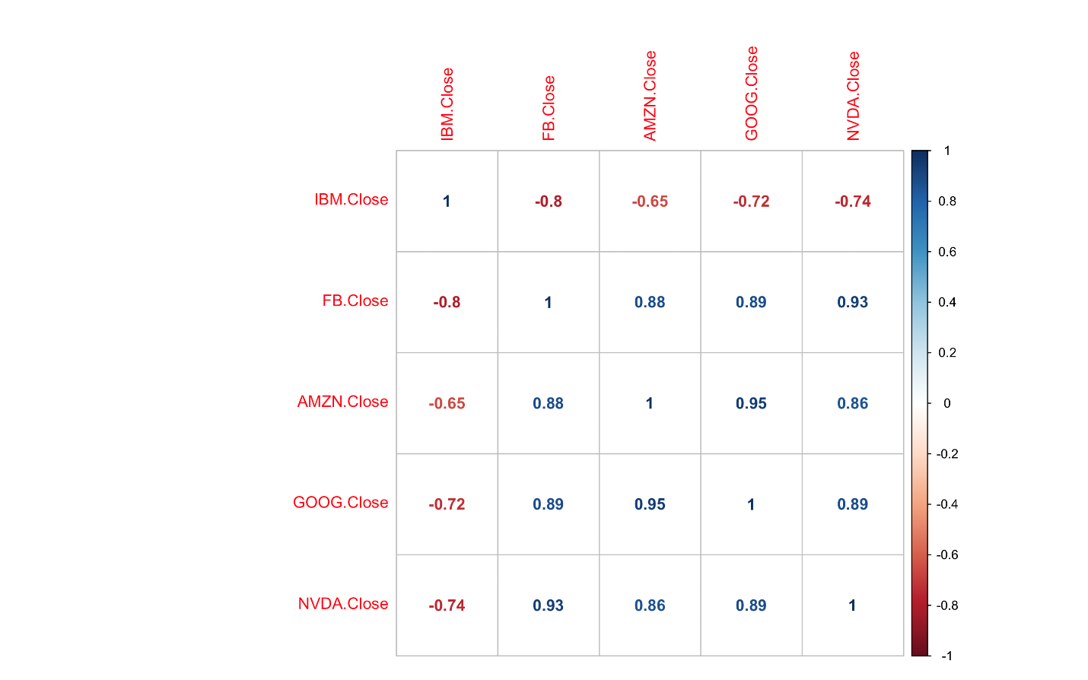

GOOG offset by -1 day with other companies: Correlation with amazon is affected.

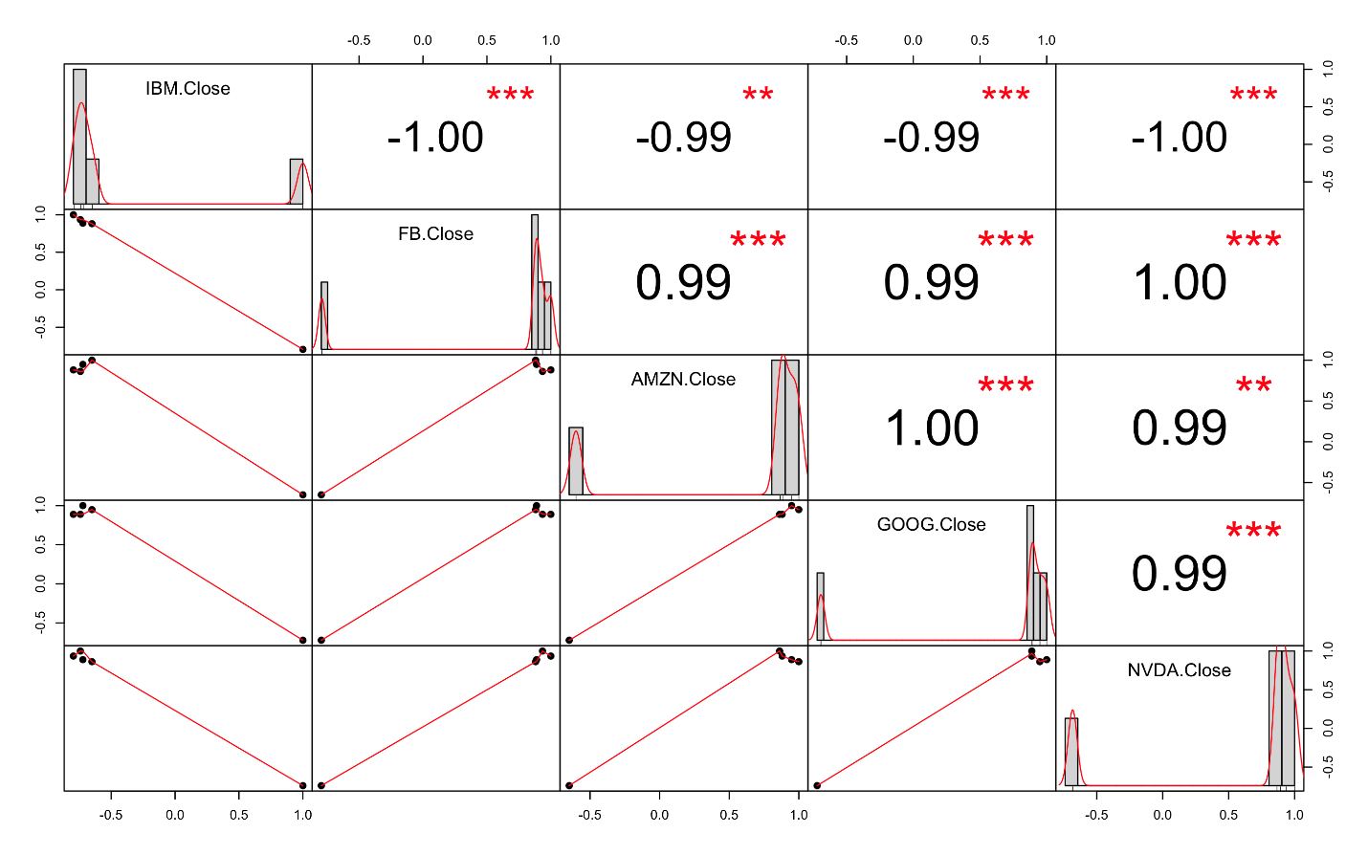

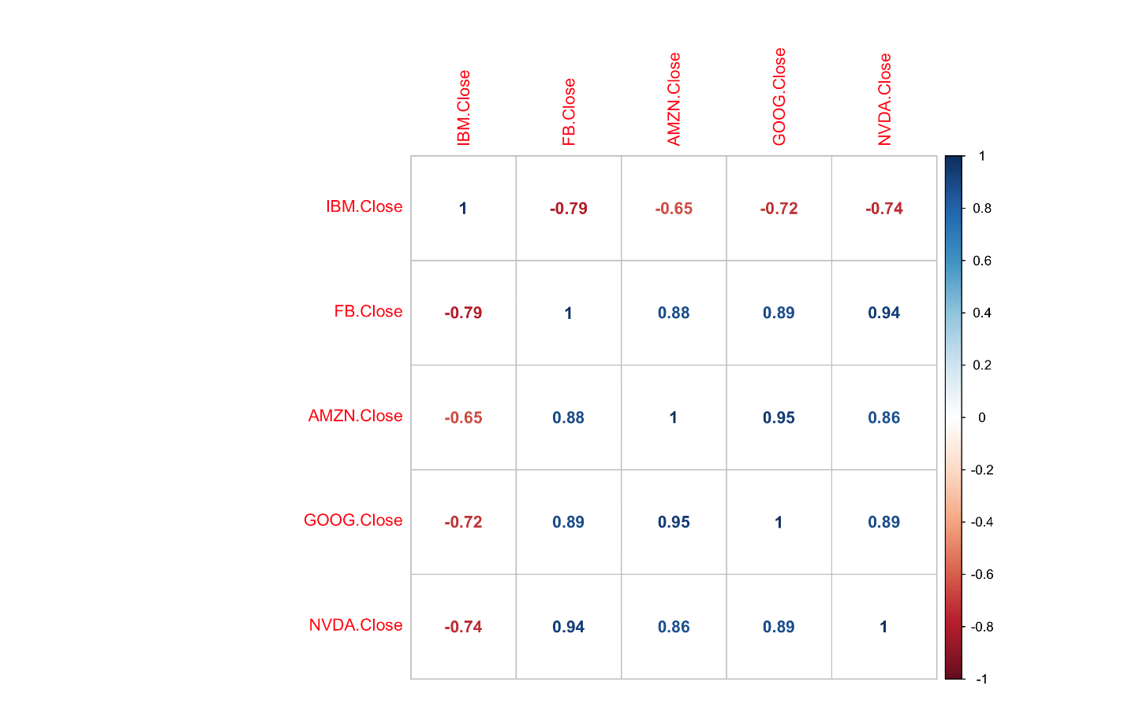

GOOG offset by +1 day with other companies: correlation with amazon has been affected

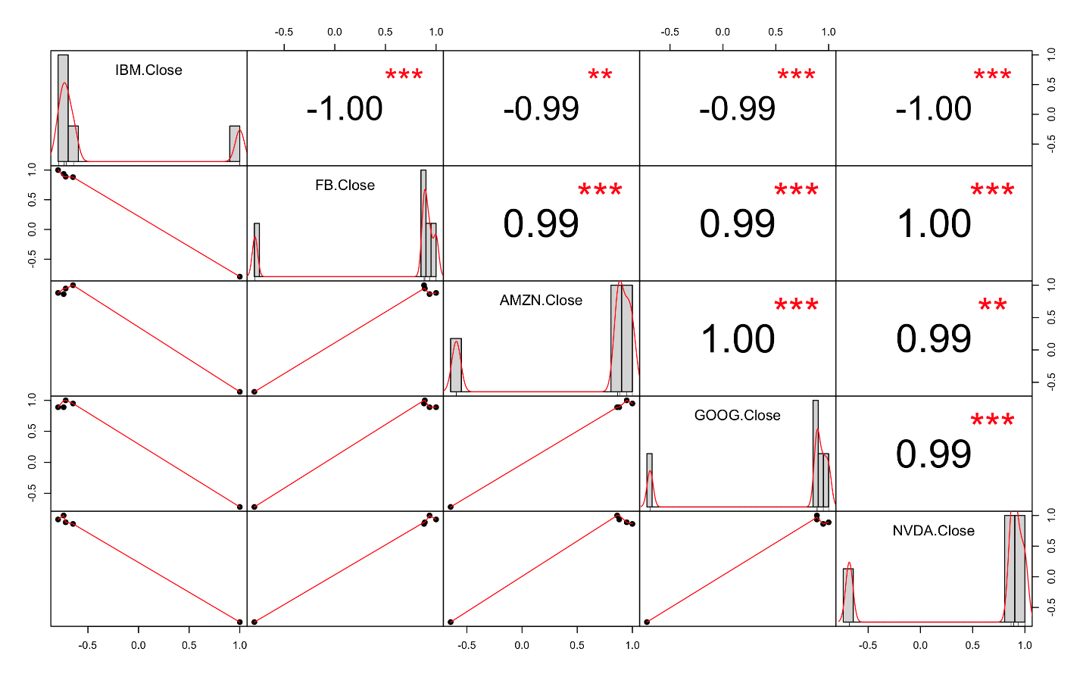

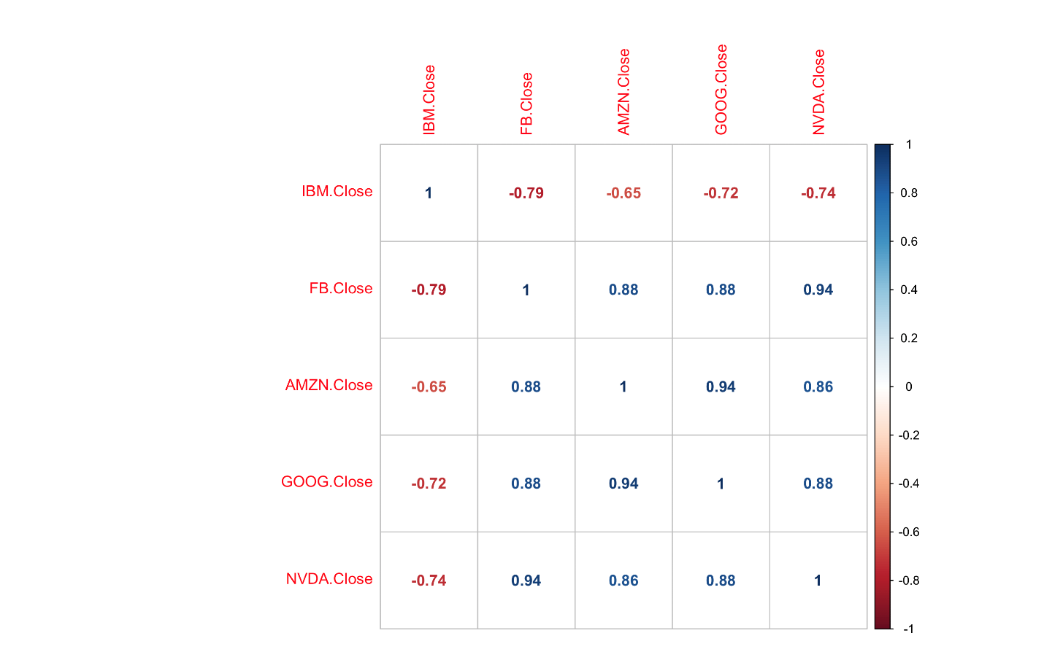

GOOG offset by +2 days with other companies: Correlation values have been decreased which means there is negative correlation between companies.

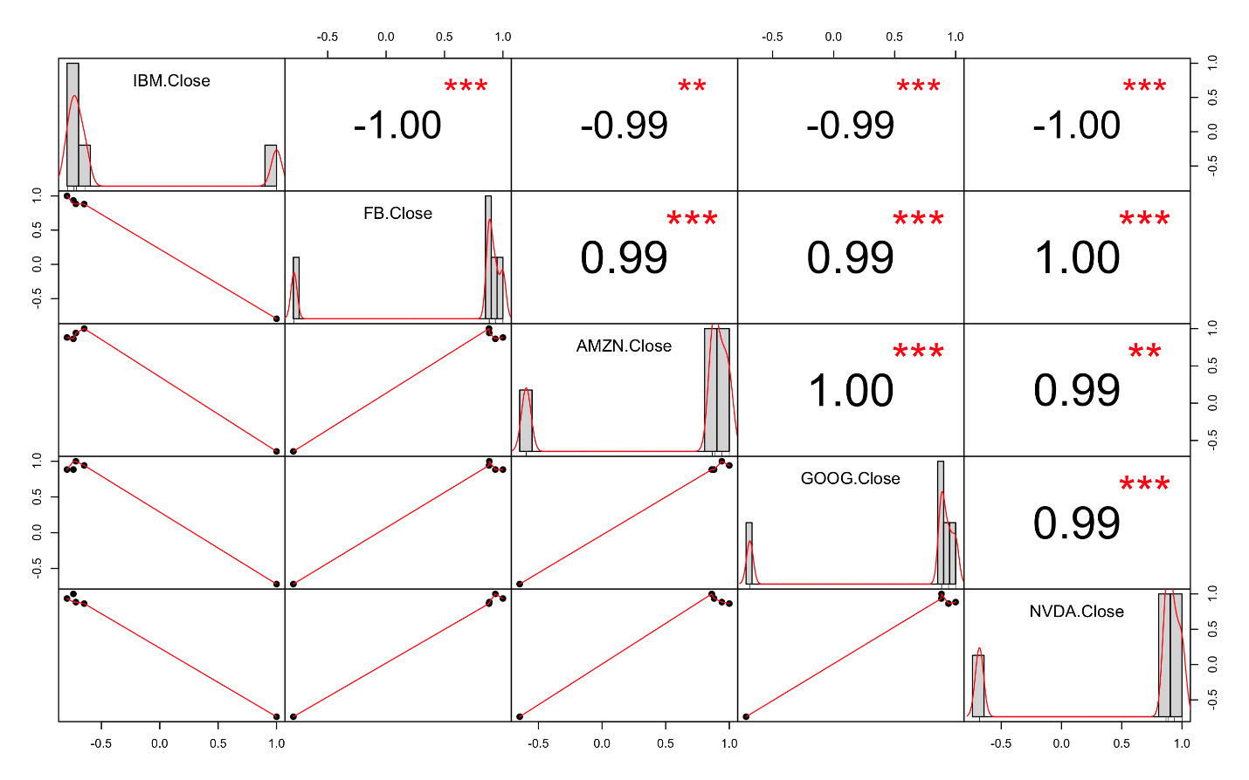

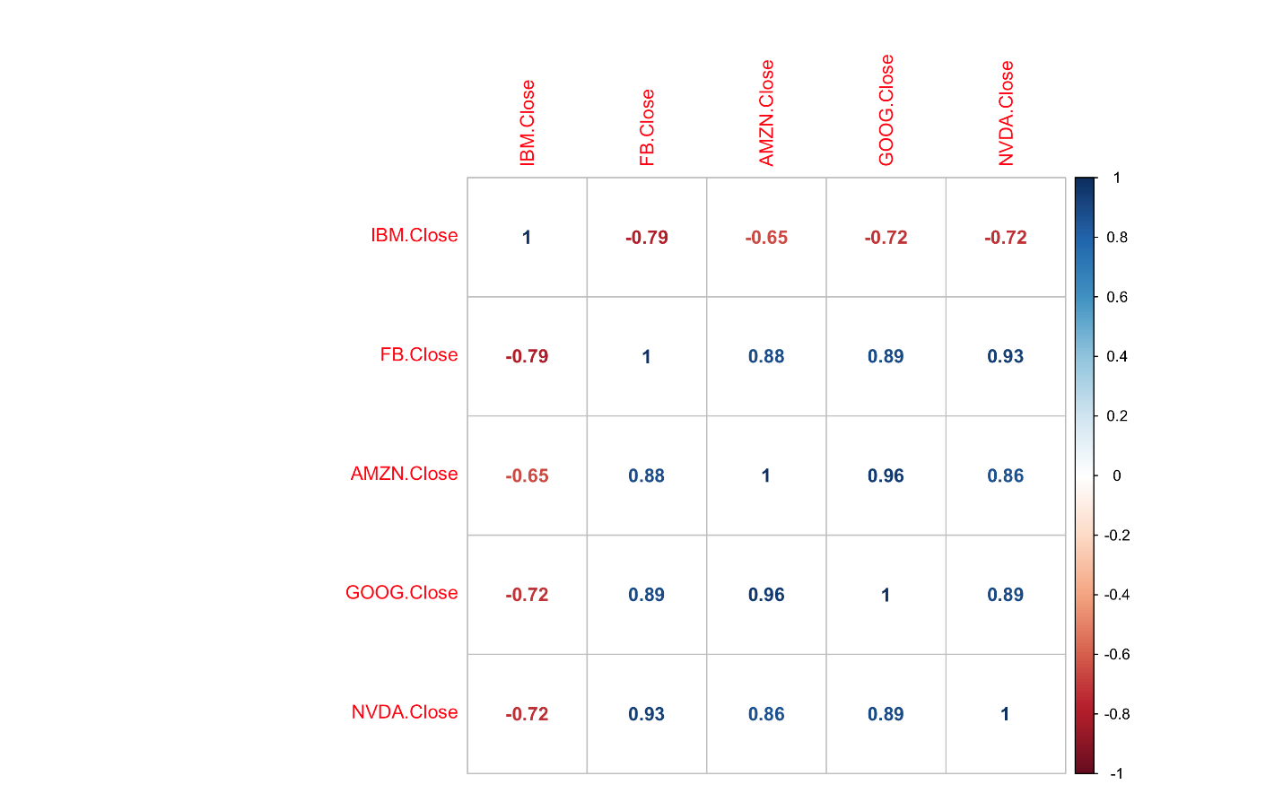

IBM offset by -2 days with other companies: Correlation has decreased with AMZN and increased with NVDA

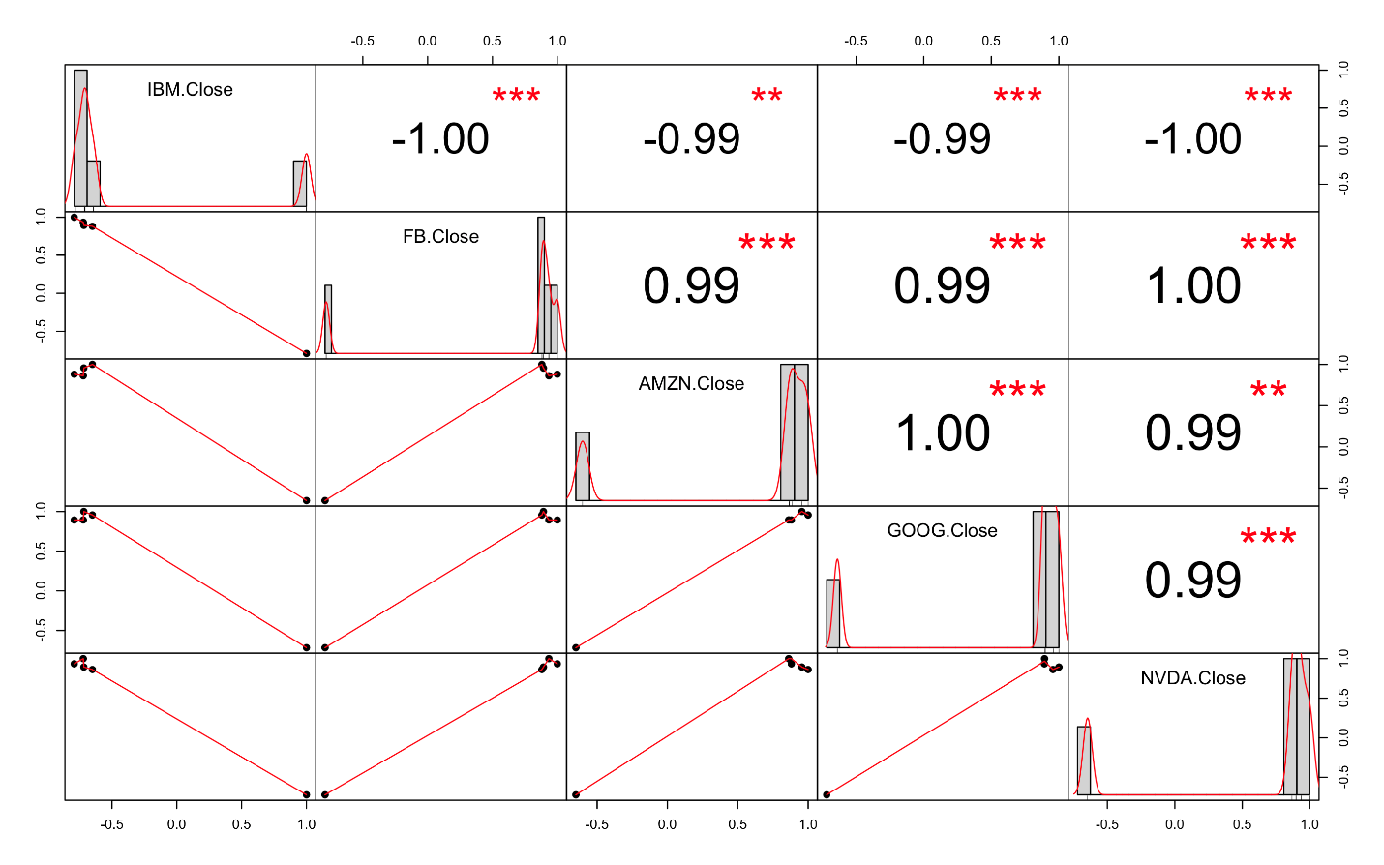

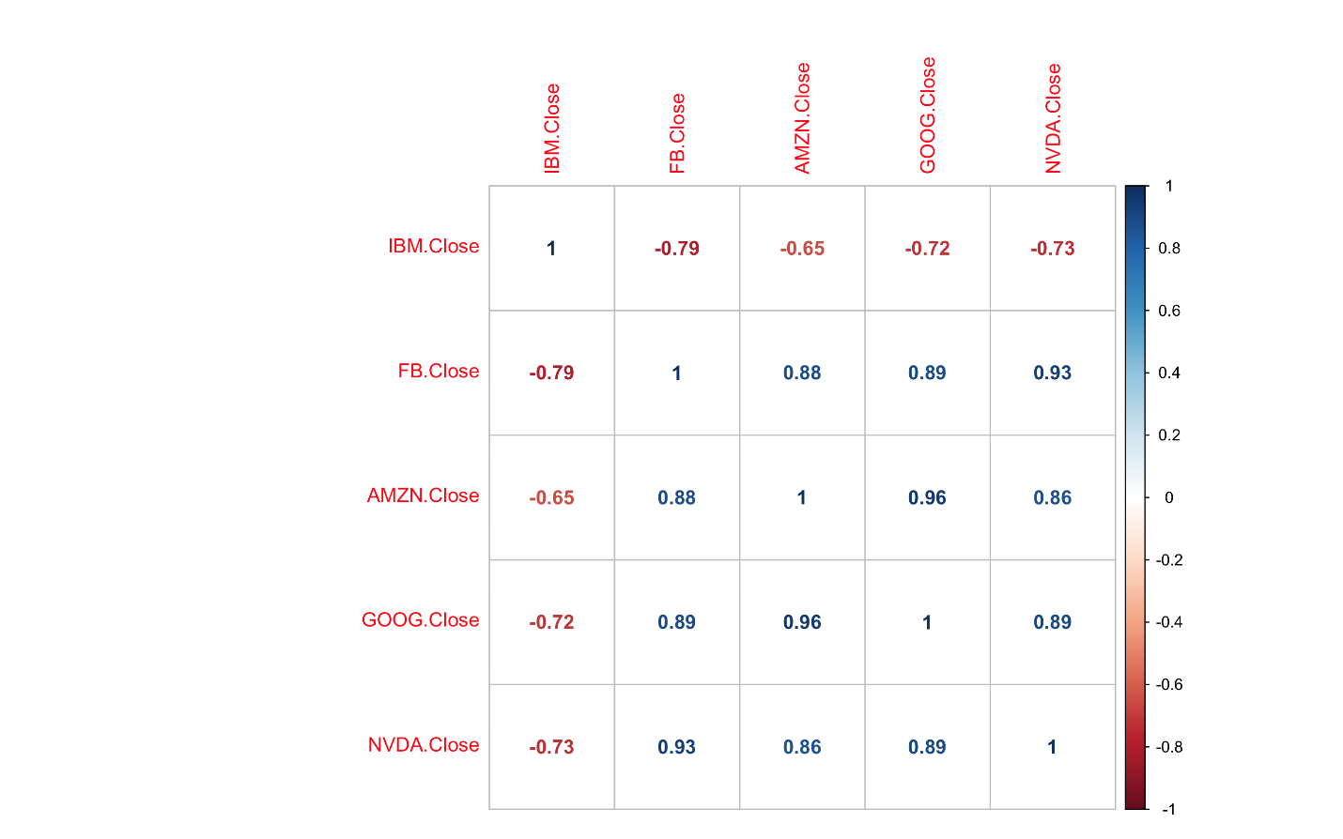

IBM offset by -1 day with other companies: Same relation as before

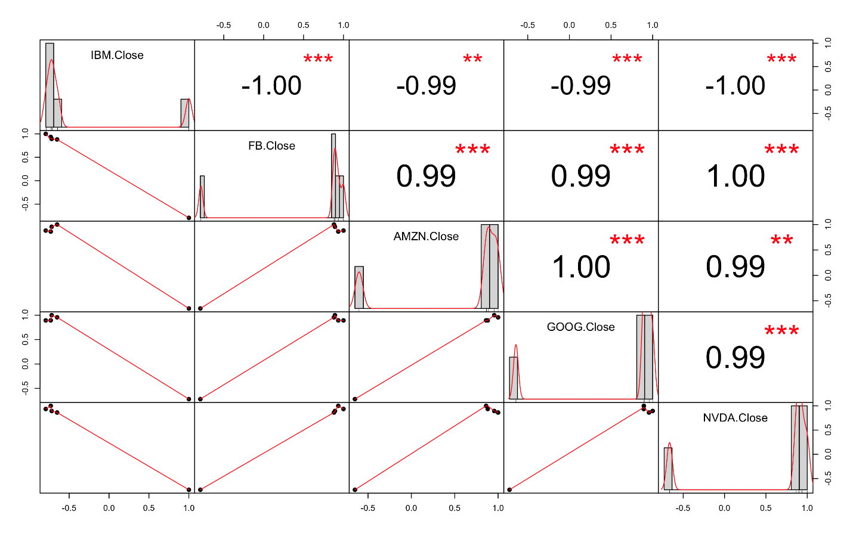

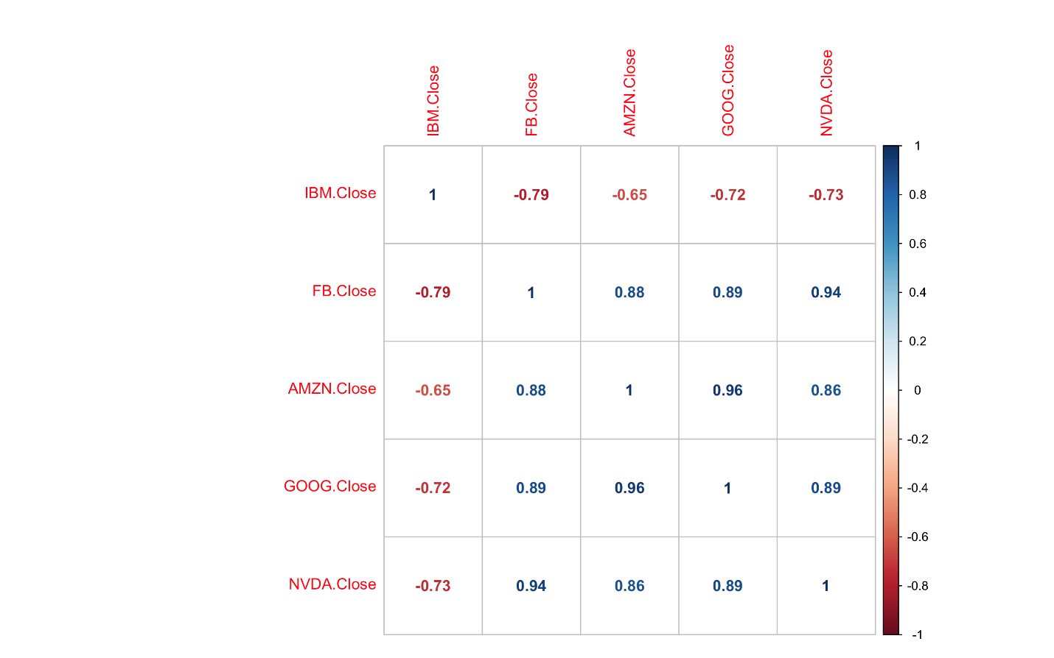

IBM offset by +1 day with other companies: Positive correlation with AMZN and NVDA

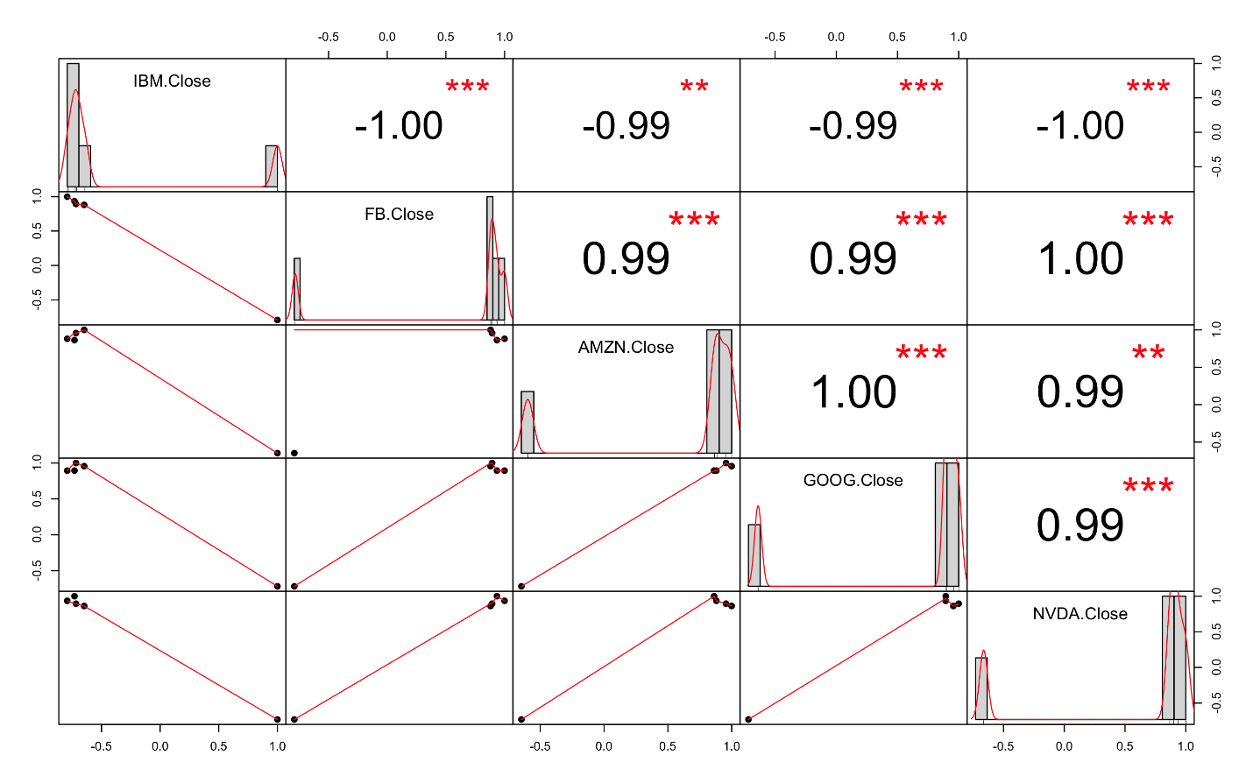

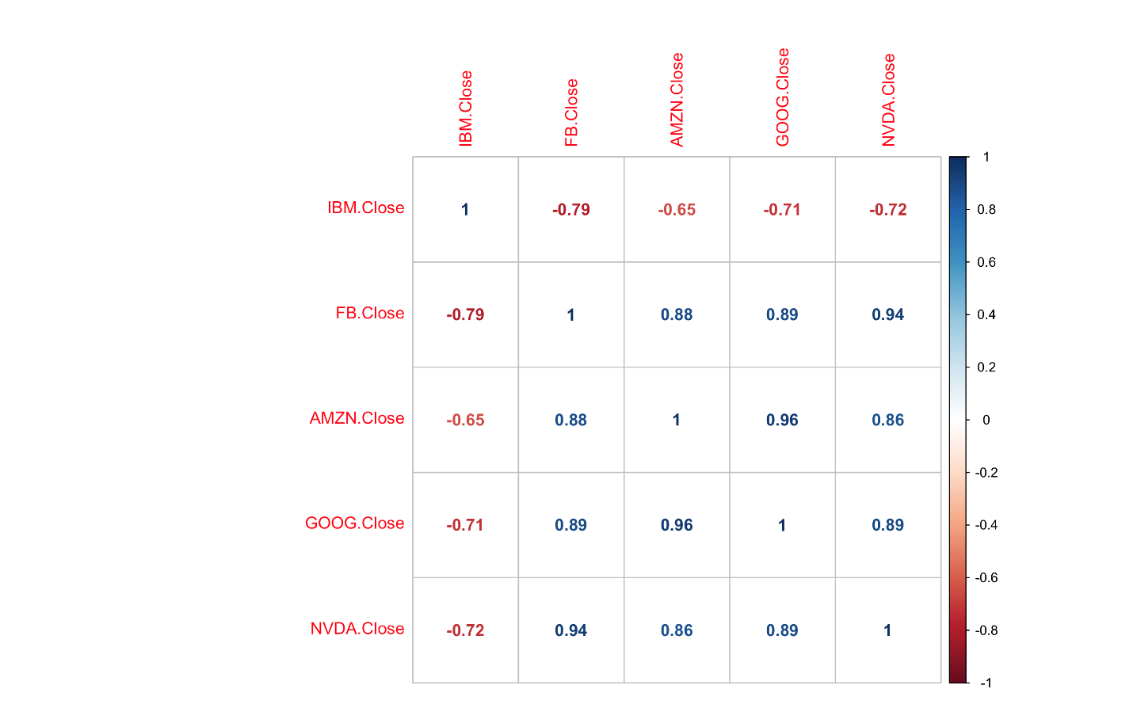

IBM offset by +2 days: Correlation decrease with AMZN and increase with NVDA

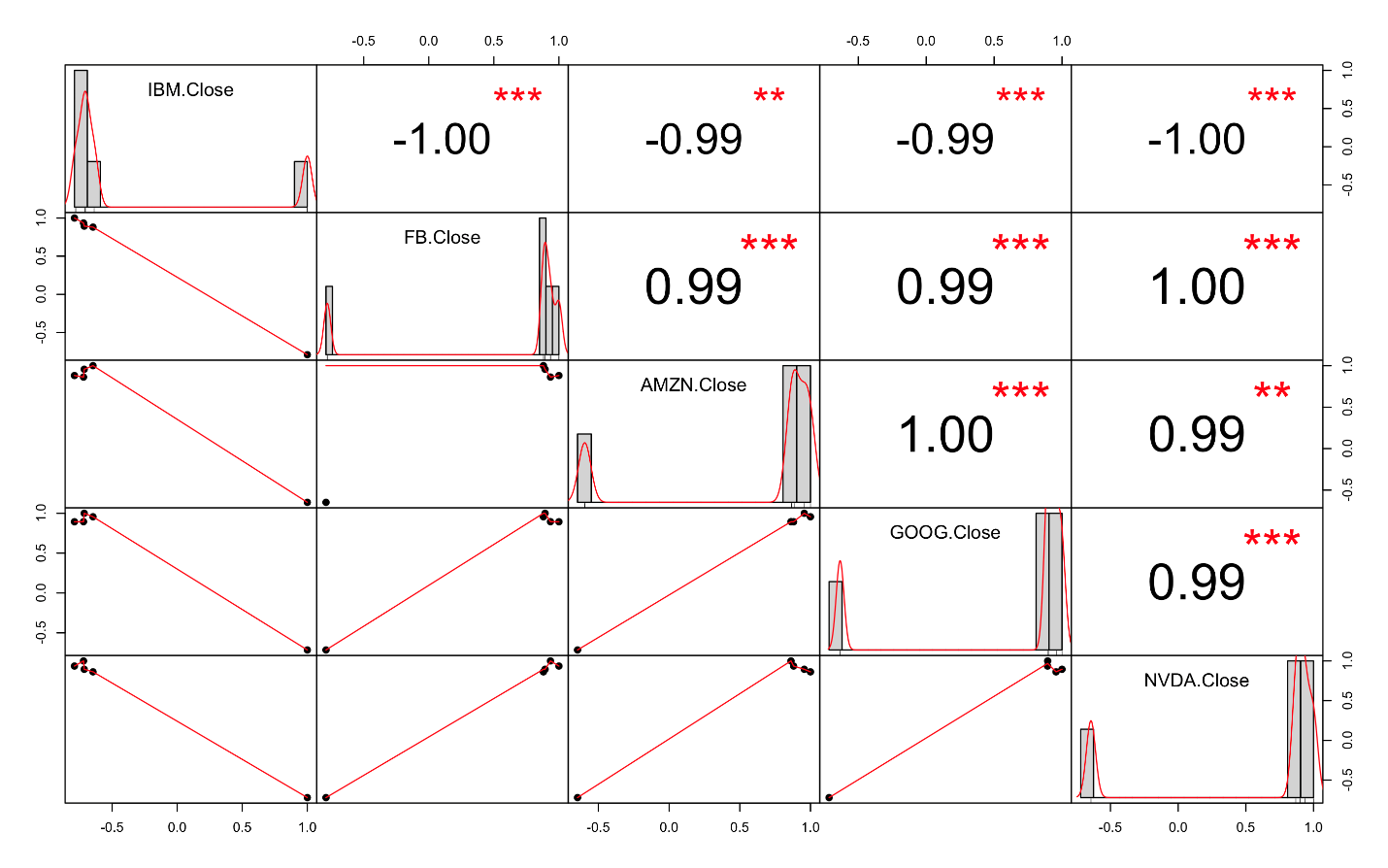

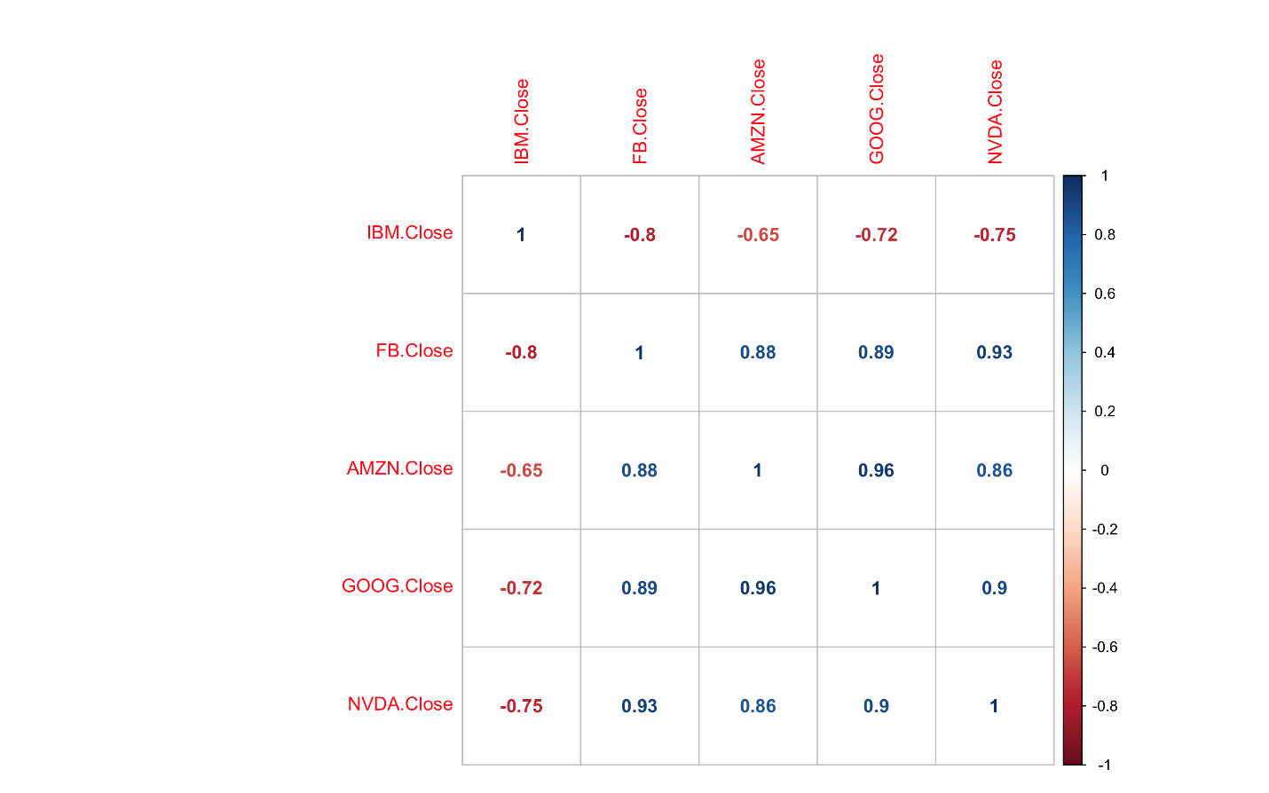

NVDA offset by -2 days: Positive correlation with NVDA and negative correlation with FB

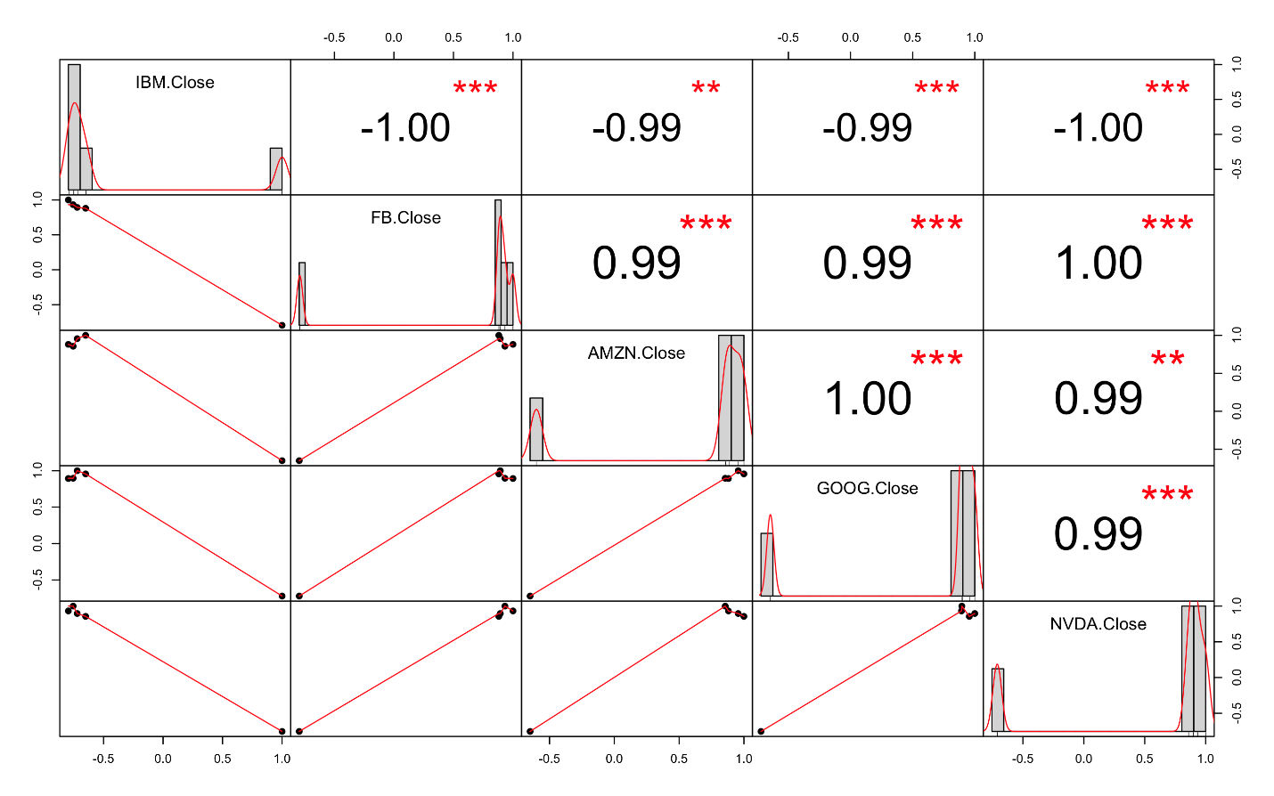

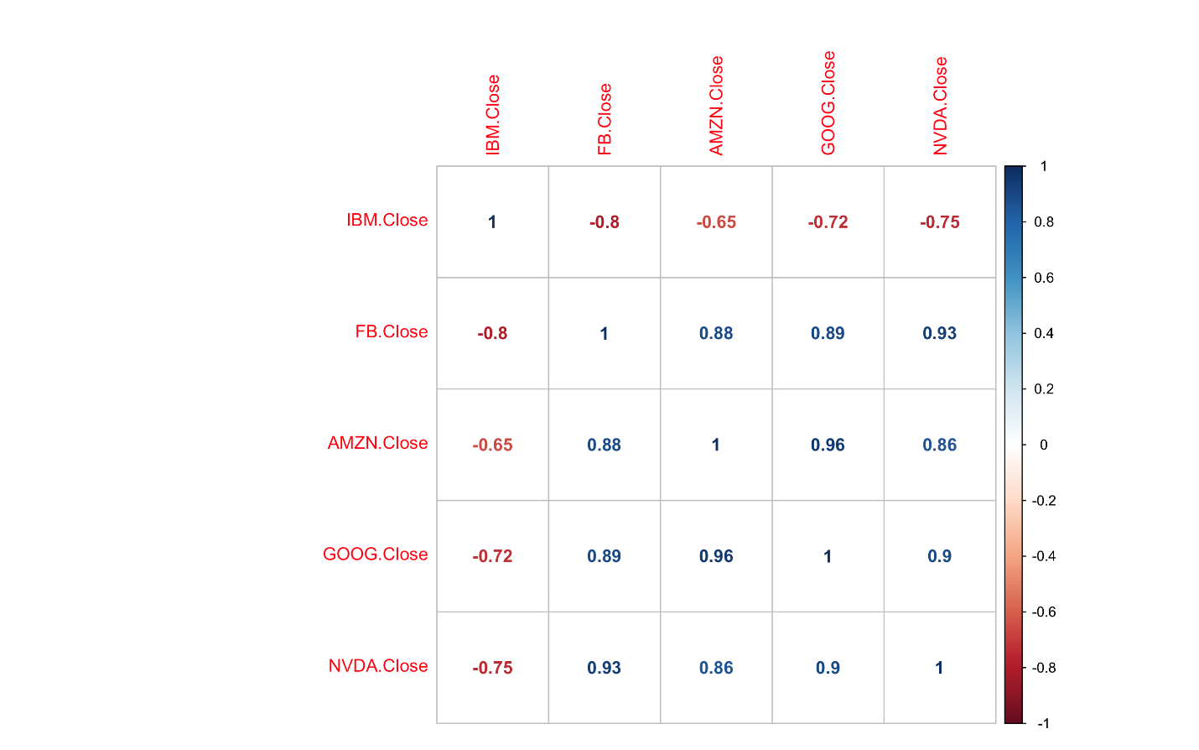

NVDA offset by -1 day: Negative correlation with IBM and FB, positive with GOOG

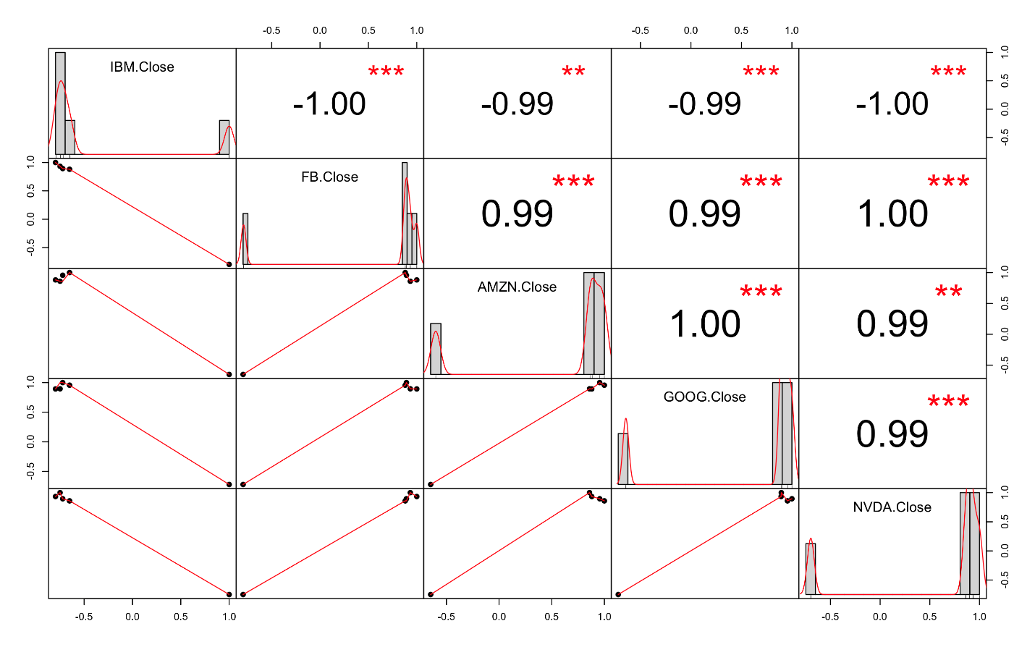

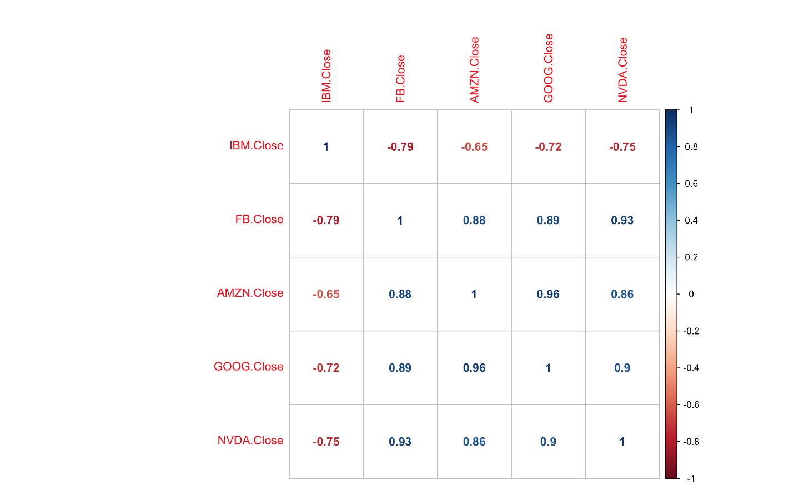

NVDA offset by +1 day: Same as before

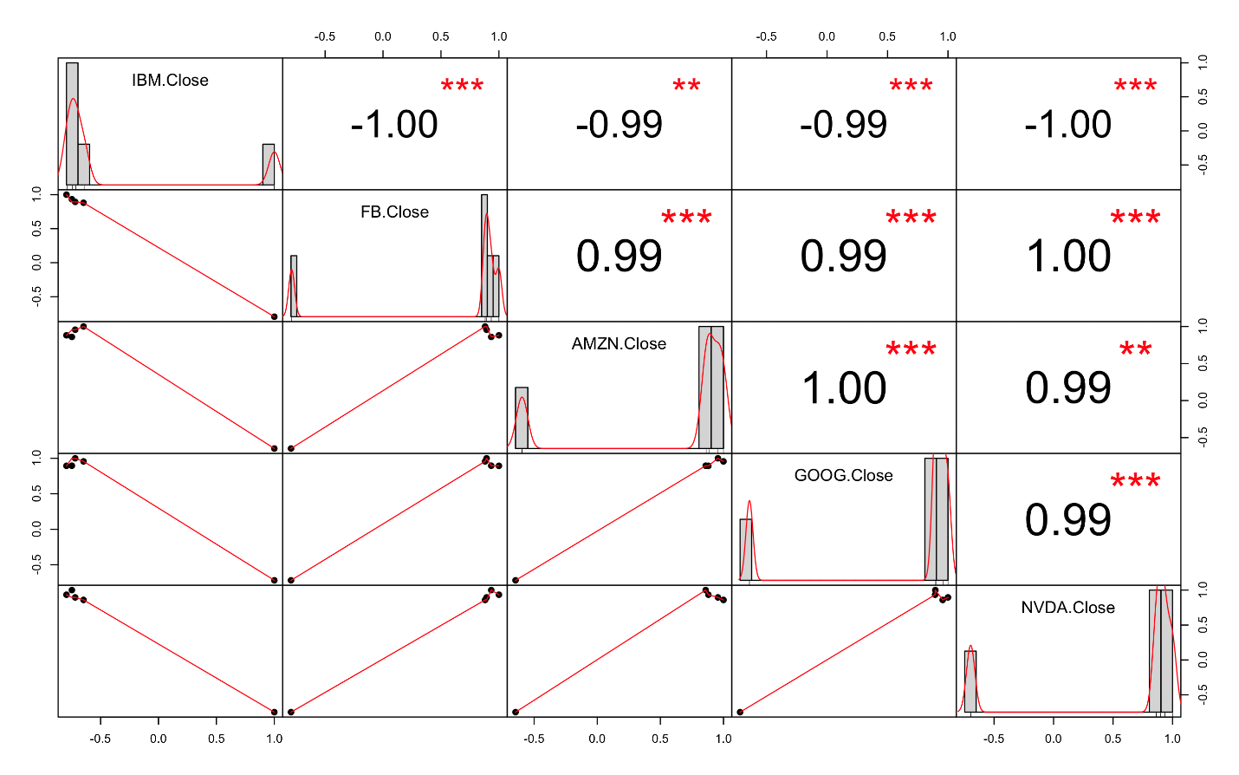

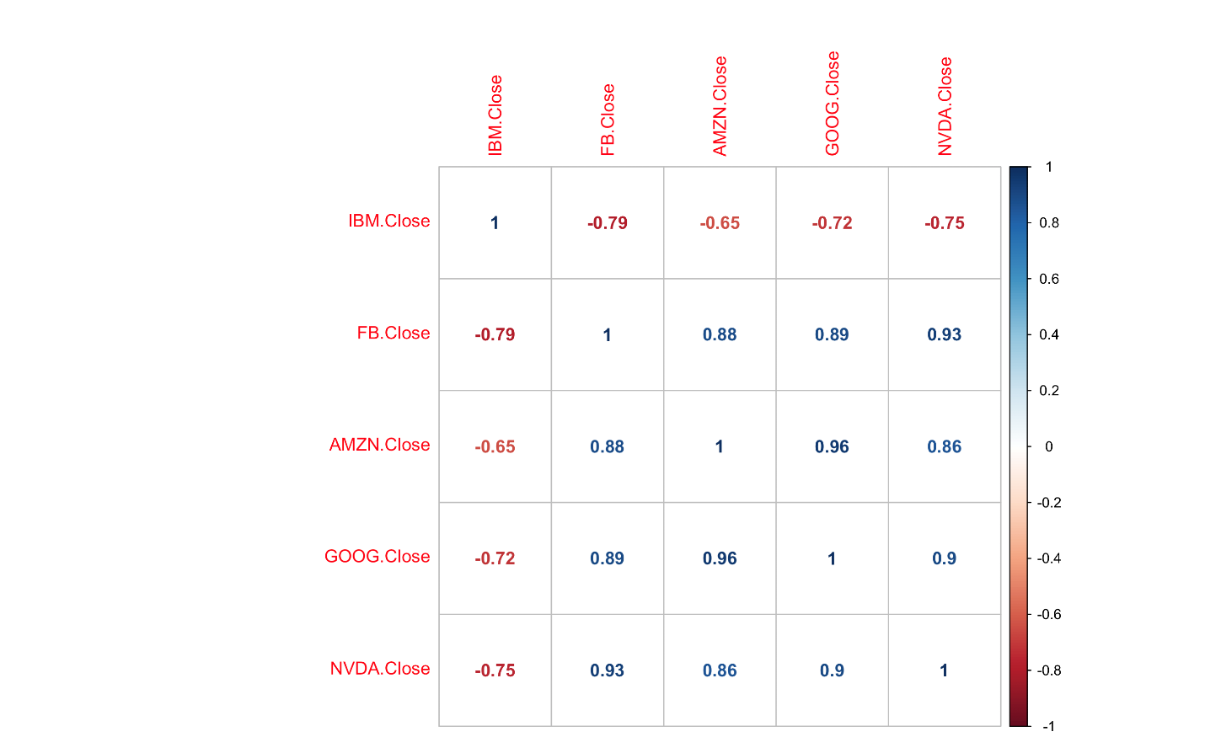

NVDA offset by +2 days: Same as before

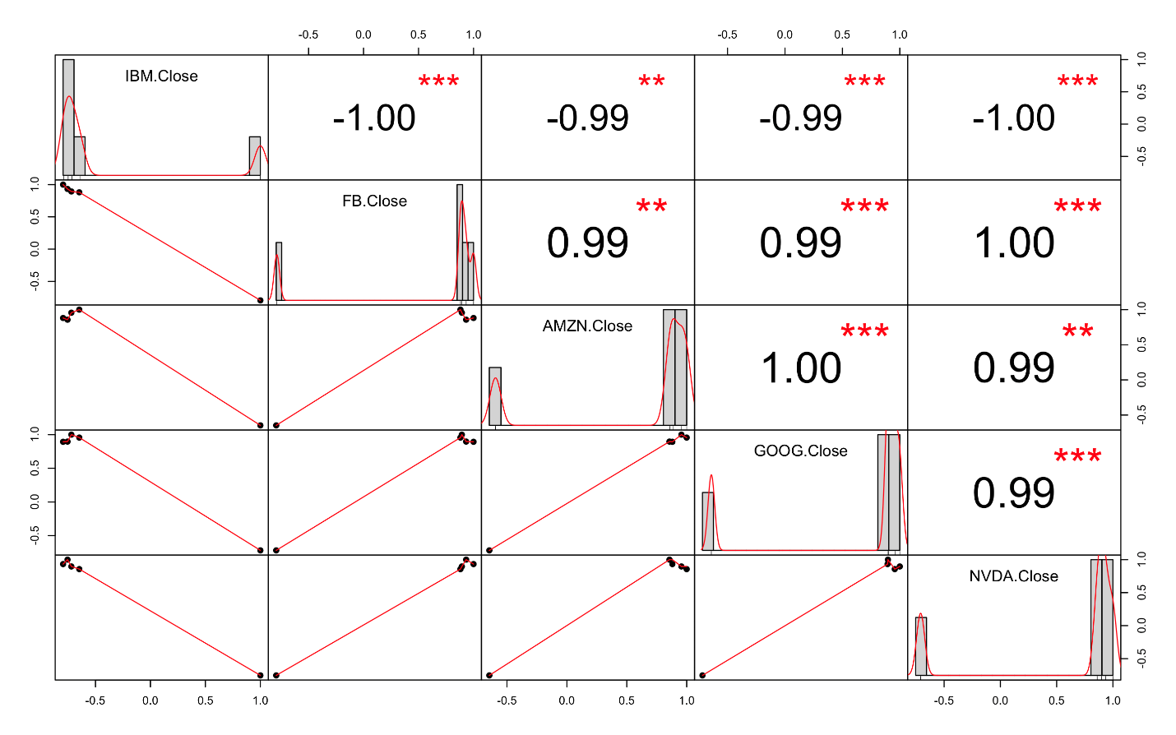

* Interpreting the results

From the observations made above, IBM has a negative correlation with all other companies. All of them are positively correlated with each other. FB and NVDA, AMZN and GOOG are strongly positively correlated with each other. Of the given companies, IBM and FB are strongly negatively correlated with each other. The results of the experiment have been described in detail for each offset as above.

* Conclusion

The results for each experiment show how the companies are correlated with each other. If two companies are correlated with each other, it can be said that the companies are linearly related with each other. From this, a predictive analysis can be made for future stocks.